Sreeti Ravi

Analyzing Hurricane Sandy Events

Copying files into VM



Creating a directory in HDFS



Copying files into data-lake directory

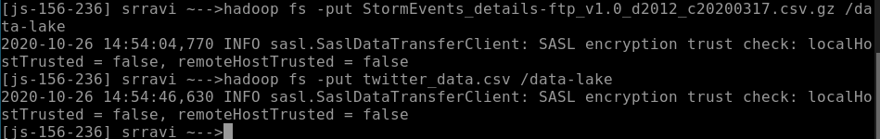

Creating dataframes

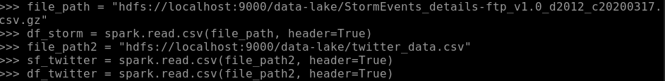

I tried to split and use explode(), but I couldn’t get it working. I spent a lot of hours trying to get it to work and I couldn’t, so this is all I have.